Mugisha ufitinema chrispin

**Real Estate Platform User Documentation**

Welcome to the Real Estate Platform! This guide will help you navigate through the platform's features, including logging in, uploading properties, and providing valuable suggestions.

Table of Contents

1. Getting Started

- 1.1 Account Login

- 1.2 Account Creation

2. Uploading Properties

- 2.1 Navigating to Property Upload

- 2.2 Adding Property Details

- 2.3 Uploading Property Images

3. Providing Suggestions

- 3.1 Navigating to Suggestions

- 3.2 Submitting a Suggestion

4. Conclusion

1**. Getting Started**

1.1 Account Login

If you already have an account, follow these steps to log in:

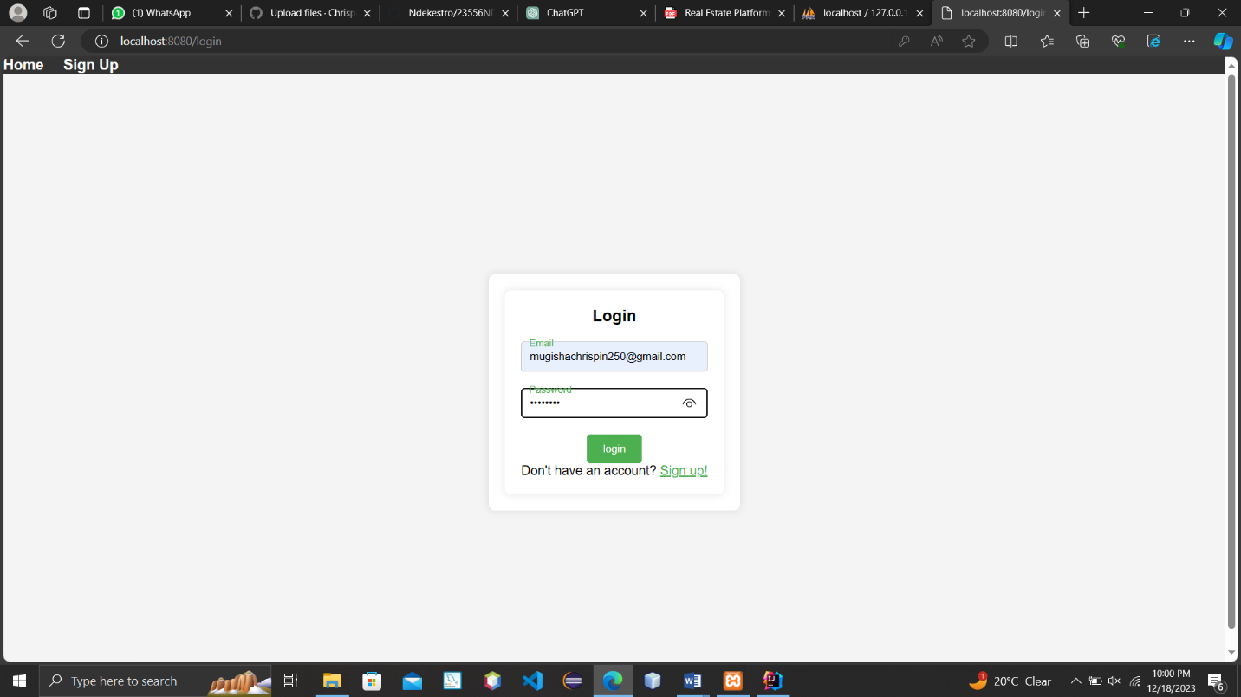

1. Open your web browser and go to the Real Estate Platform website.

2. Click on the "Login" link.

3. Enter your username and password.

4. Click the "Login" button.

**1.2 Account Creation**

If you are new to the platform, you can create an account:

1. Open your web browser and go to the Real Estate Platform website.

2. Click on the "Sign Up" or "Register" link.

3. Fill in the required information (username, email, password).

4. Click the "Sign Up" or "Register" button.

5. Check your email for a confirmation link and follow the instructions to verify your account.

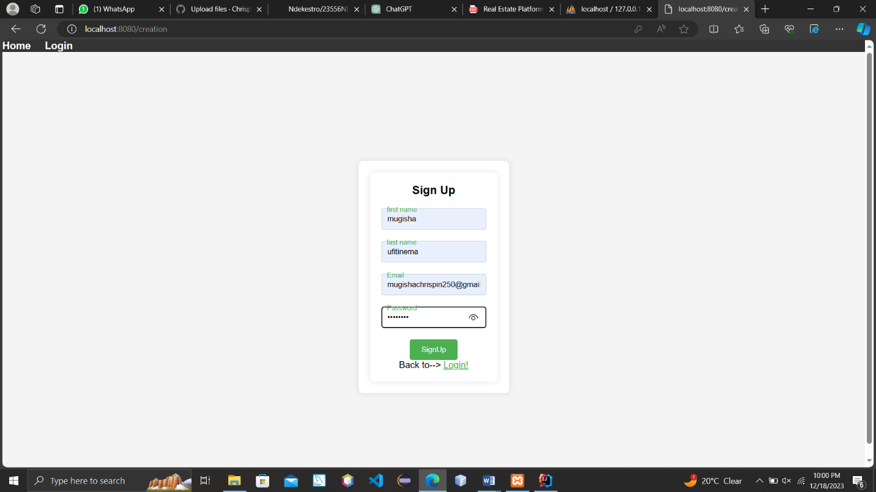

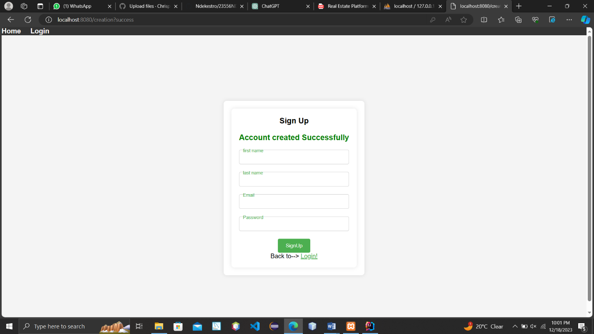

**2. Uploading Properties**

**2.1 Navigating to Property Upload**

After logging in, you can upload your property details:

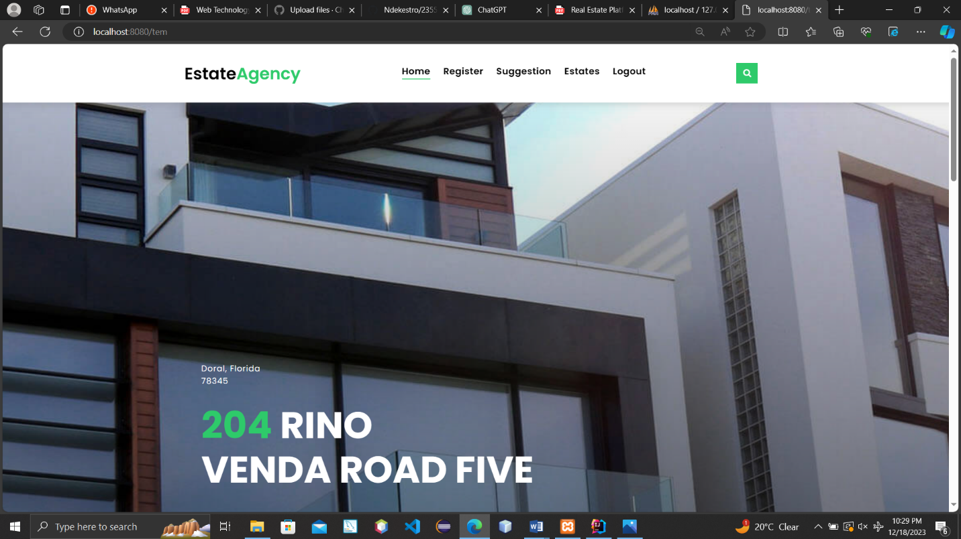

1. On the dashboard, look for the "register" or similar option.

2. Click on the "Upload Property" link to access the property upload form.

**2.2 Adding Property Details**

1. Fill in the required details for your property, such as location, size, and features.

2. Provide accurate information to attract potential buyers.

3. Double-check the information before submitting to ensure accuracy.

**2.3 Uploading Property Images**

1. Add high-quality images of your property to enhance the listing.

2. Click on the "Upload Images" button and select the images from your computer.

3. Ensure the images showcase the property effectively.

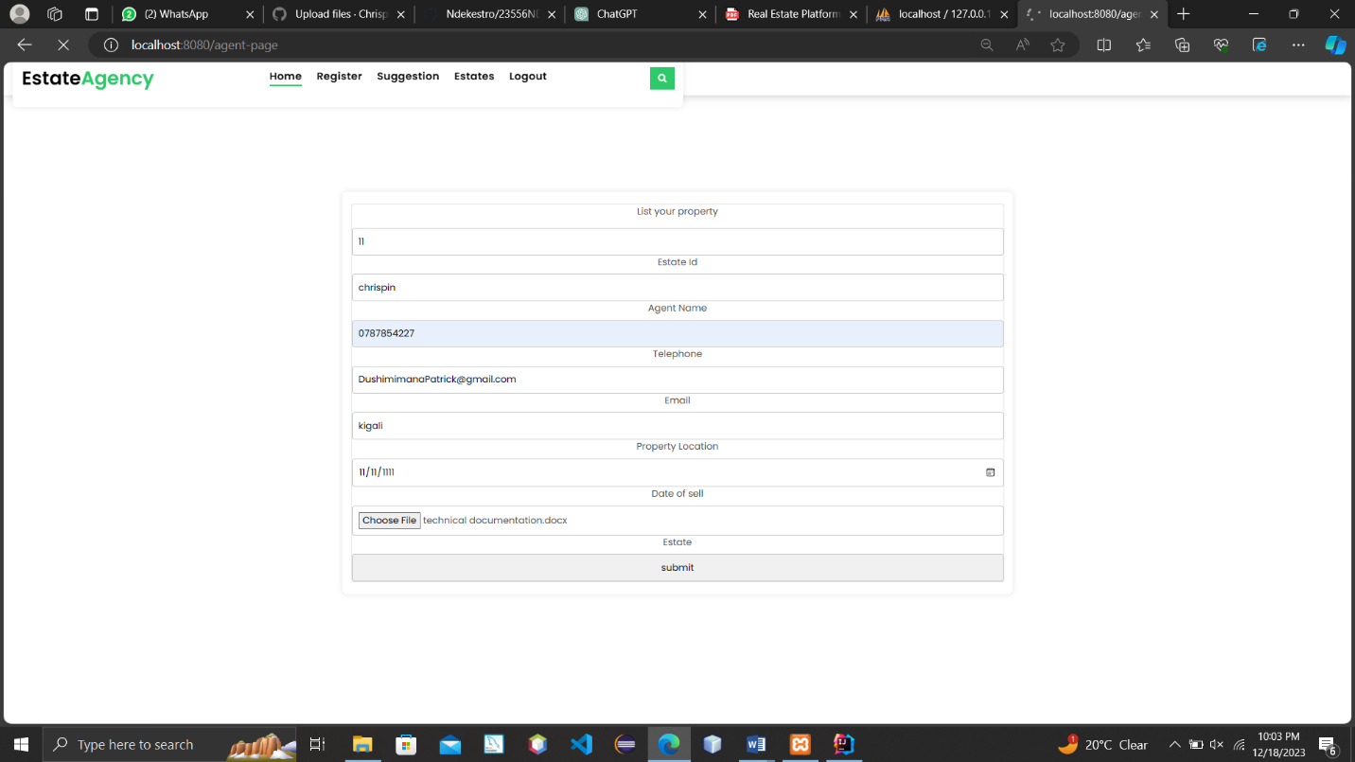

---

**3. Providing Suggestions**

3.1 Navigating to Suggestions

Your feedback is important! Here's how you can provide suggestions:

1. Look for the "Suggestions" or "Feedback" section on the platform.

2. Click on the "Suggestions" link to access the feedback form.



**3.2 Submitting a Suggestion**

1. Fill in the suggestion form, expressing your thoughts or ideas.

2. Be specific and clear to help us understand your suggestion better.

3. Click the "Submit" or "Send" button to submit your suggestion.

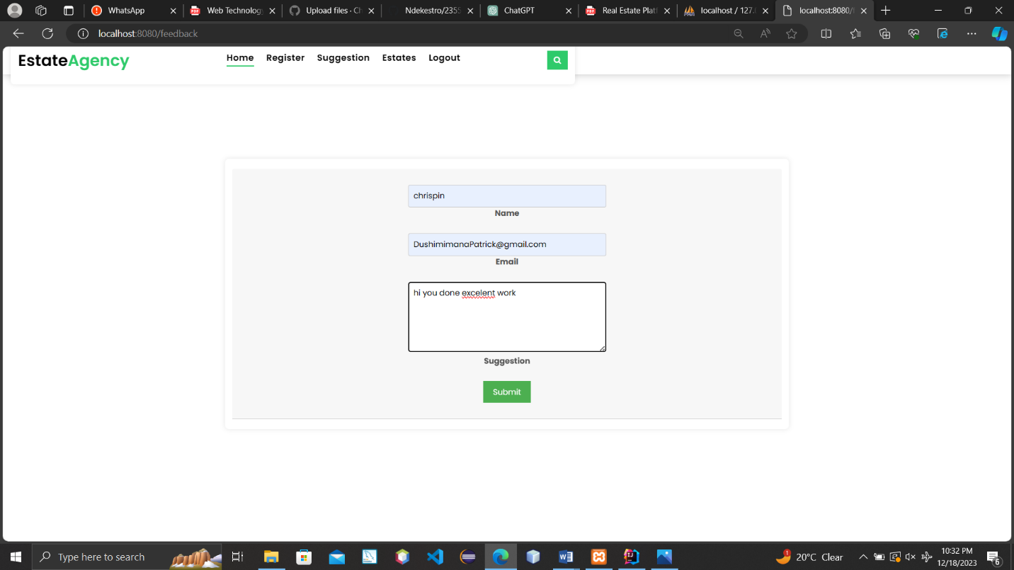

**4. Conclusion**

Congratulations! You've successfully logged in, uploaded your property, and provided valuable suggestions. The Real Estate Platform appreciates your participation and aims to make your property transactions as seamless as possible.

If you encounter any issues or have further questions, feel free to reach out to our support team through the contact information provided on the platform.

Thank you for being a part of our Real Estate community!